IncrediBuild Predictive Execution
This feature in IncrediBuild (IB) optimizes build performance. IB flattens the build and works out which files have no dependencies and builds these files first. Predictive Execution can build and parallelize more files at the same time since traditional build order is ignored and replaced by true dependency order instead. Predictive Execution can be enabled / disabled as shown below.
- To Enable Predictive Execution

- Open IB agent settings and tick the Enhance throughput feature as shown below.

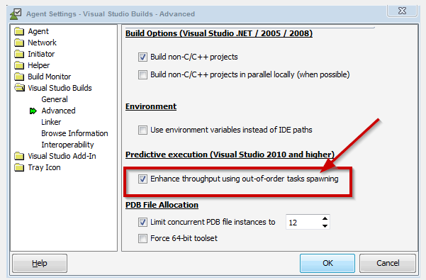

Add a registry key to control the maximum MSBuild version as follows:

b) Open Registry Editor “regedit”

c) Add a new key in the following location:
HKEY_CURRENT_USER -> Software -> Xoreax -> Incredibuild -> Builder

d) Add Key:
Key Name: MSBuildMaxSupportVersion14.0
Key type: String
Key Value: 14.025420.1

e) Should look as follows in regedit
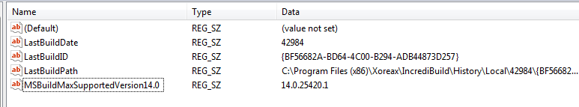

- Choice 2 - Disable Predictive Execution

Open IB agent settings and untick the Enhance throughput feature as shown below.

